CONTENTS

CHAPTER 1: INTRODUCTION TO PROJECT

Introduction

In the era of digital transformation, organizations generate vast volumes of structured and unstructured data. Extracting actionable insights from this data is critical for strategic decision-making. However, traditional data analysis processes are manual, time-consuming, and require domain expertise.

The proposed project, “AI-Powered Data Analyst Agent”, aims to automate the complete data analysis lifecycle by integrating data processing, exploratory data analysis (EDA), and intelligent insight generation into a unified system. The system simulates the role of a professional data analyst by not only analyzing data but also providing contextual business recommendations.

Objective of the Project

The primary objectives are:

To design an automated data analysis pipeline

To perform intelligent EDA using Python-based tools

To generate context-aware insights from datasets

To provide actionable business strategies

To develop an interactive user interface

Scope of the Project

The system can be applied in:

Business intelligence and analytics

Sales and marketing optimization

Customer behavior analysis

Academic and research environments

Problem Statement

Existing data analysis tools primarily focus on visualization and require human interpretation to derive insights. There is a need for an intelligent system that can automate both analysis and interpretation, reducing dependency on manual effort.

System Overview

The system accepts structured datasets (CSV/Excel), processes them using Python, performs EDA, and generates insights and business strategies using a rule-based or AI-driven engine. The results are displayed through an interactive dashboard.

CHAPTER 2: BACKGROUND AND MOTIVATION

2.1 Background of Data Analytics

Data analytics involves collecting, processing, and analyzing data to extract meaningful patterns. Traditional tools such as spreadsheets and SQL-based systems provide raw outputs but lack automated interpretation capabilities.

2.2 Theoretical Foundation

2.2.1 Exploratory Data Analysis (EDA)

EDA is a fundamental step in data science used to summarize data characteristics through statistical measures and visualization techniques.

2.2.2 Statistical Analysis

Includes measures such as mean, median, variance, and correlation to understand data distribution and relationships.

2.2.3 Artificial Intelligence in Analytics

AI enables systems to interpret data patterns and generate human-like insights, reducing manual effort.

2.3 Motivation

The motivation behind this project includes:

Increasing demand for automated analytics solutions

Need for faster decision-making

Reducing dependency on skilled analysts

Bridging the gap between data and business decisions

2.4 Limitations of Existing Systems

Require manual interpretation

Lack automated recommendations

Not user-friendly for non-technical users

2.5 Software Tools and Technologies

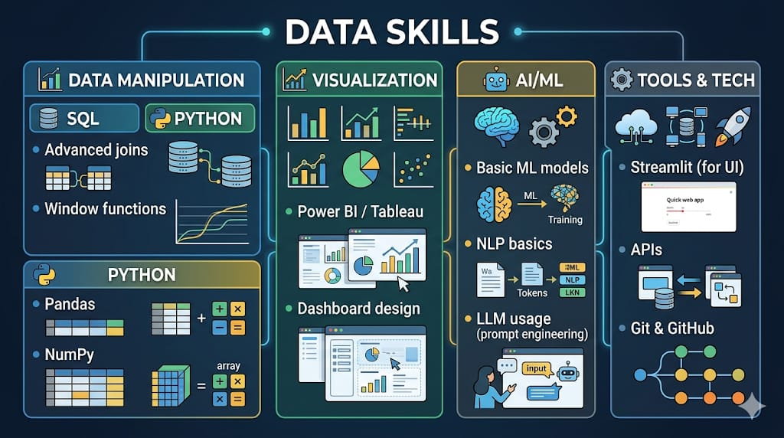

CHAPTER 3: LITERATURE SURVEY

3.1 Overview of Existing Research

Several research studies and tools have been developed in the field of data analytics, focusing on visualization and predictive modeling. However, automated insight generation remains a developing area.

3.2 Review of Existing Systems

Business Intelligence dashboards

Data visualization tools

Predictive analytics systems

These systems provide analysis but lack automated decision-making capabilities.

3.3 Techniques Used in Previous Work

Data preprocessing techniques

Statistical modeling

Machine learning algorithms

Visualization techniques

3.4 Identified Research Gaps

Lack of automation in insight generation

No integrated strategy recommendation system

Limited accessibility for non-expert users

3.5 Proposed System Contribution

The proposed system addresses these gaps by:

Automating EDA

Generating insights automatically

Providing actionable business strategies

Offering a user-friendly interface

CHAPTER 4: PROJECT WORK

4.1 Problem Definition

To develop an intelligent system capable of performing automated data analysis and generating business insights and strategies without human intervention.

4.2 Objectives

Automate data preprocessing and analysis

Generate meaningful insights

Provide strategic recommendations

Develop an interactive dashboard

4.3 Methodology

4.3.1 Data Collection

Import dataset (CSV/Excel)

4.3.2 Data Preprocessing

Handle missing values

Data cleaning and transformation

4.3.3 Exploratory Data Analysis

Statistical summaries

Trend analysis

Correlation analysis

4.3.4 Insight Generation Engine

Rule-based logic for interpreting results

4.3.5 Strategy Recommendation Engine

Mapping insights to business actions

4.3.6 Visualization

Graphical representation of data

4.4 System Architecture

The system consists of:

Data Ingestion Layer

Data Processing Layer

Insight Generation Engine

Strategy Engine

User Interface Layer

4.5 Tools and Technologies

Python

Pandas

Matplotlib

Streamlit

📊 CHAPTER 5: RESULTS AND DISCUSSION

5.1 Results

The system successfully:

Processes input datasets

Performs EDA

Generates insights and strategies

Displays results through an interactive interface

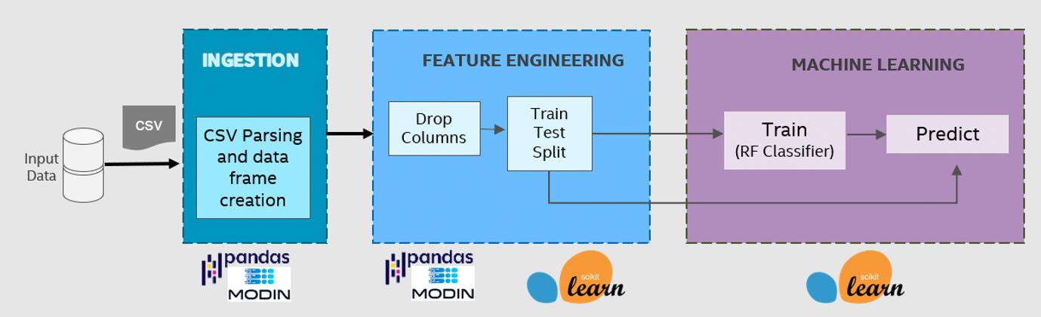

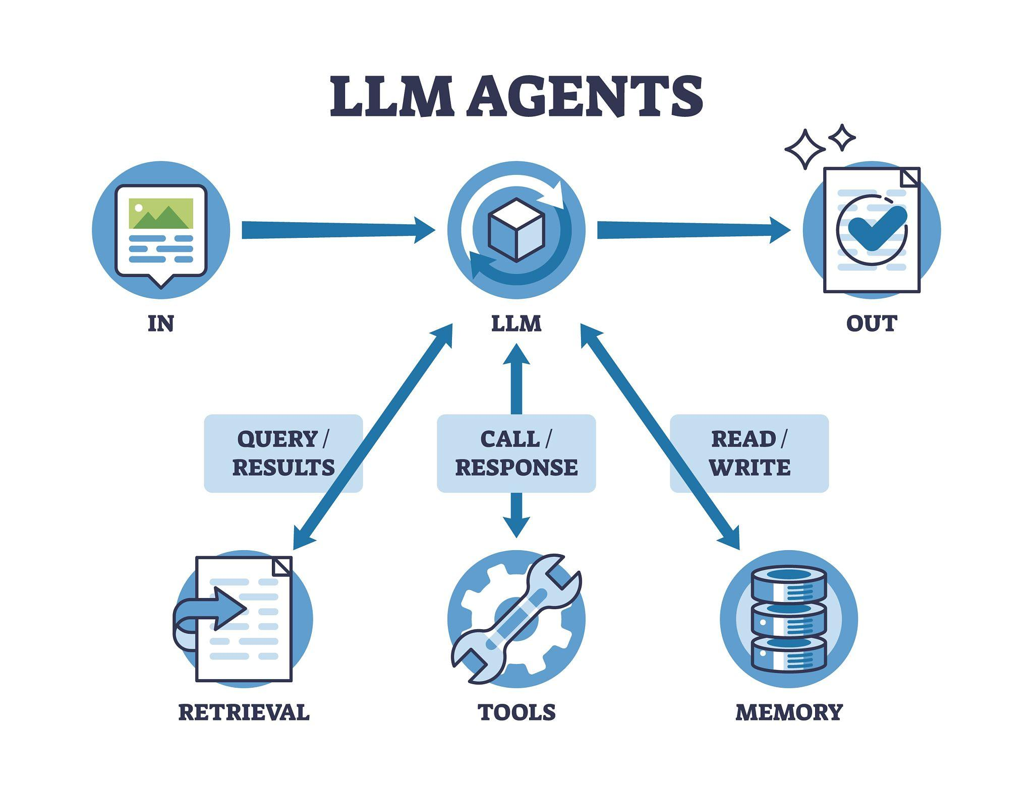

5.2 Analysis of Results

The generated insights help identify:

Performance trends

High and low-performing segments

Business opportunities

5.3 Discussion

The system improves efficiency by automating repetitive tasks. However, the quality of insights depends on the dataset and predefined logic.

CHAPTER 6: CONCLUSION AND FUTURE SCOPE

6.1 Conclusion

The project demonstrates the feasibility of automating the data analysis process using Python and AI concepts. It successfully bridges the gap between raw data and decision-making by generating insights and strategies.

6.2 Future Scope

Integration with real-time databases

Use of advanced AI/LLM models

Natural language query support

Integration with BI tools

6.3 User Interface – Input Page

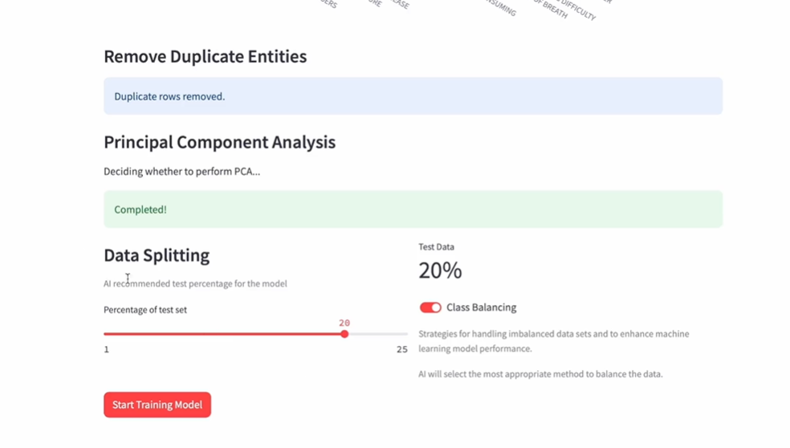

6.4 User Interface – Result/Output Page

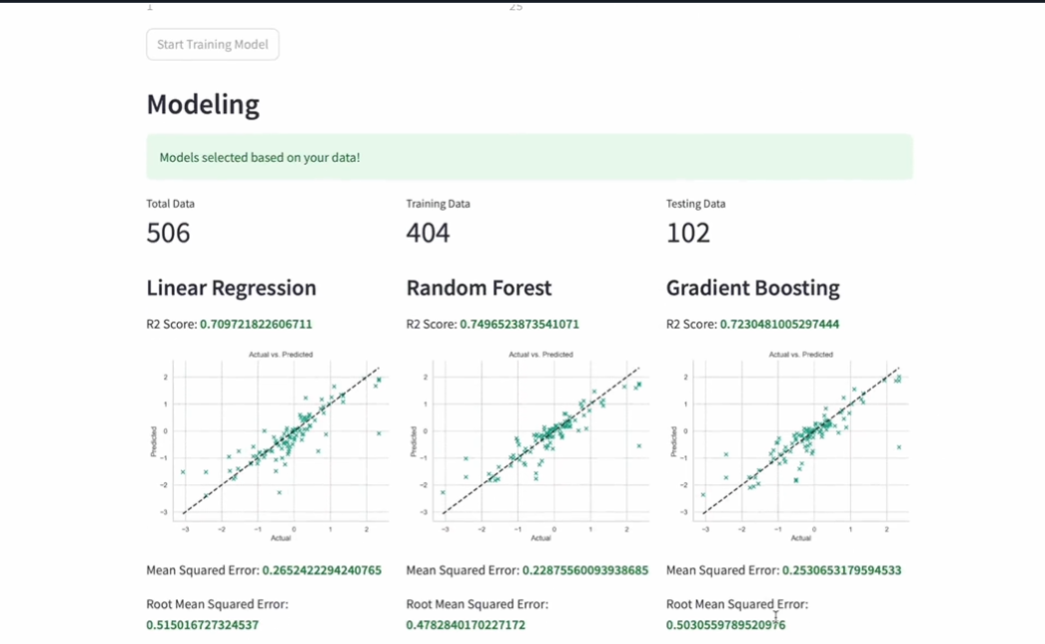

📚 REFERENCES

Python Official Documentation

Pandas Documentation

Research papers on Data Analytics

Machine Learning resources

📎 APPENDIX

Source Code

Dataset description

Screenshots of system output

User manual

